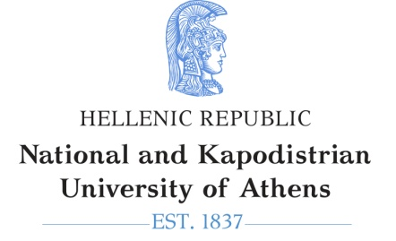
Glo/cal perspectives in translating and interpreting migration

Symposium organized by the 'Translation Studies and Interpreting' Specialization of the MA Programme 'English Language, Linguistics and Translation', Venue: Alkis Argyriadis Amphitheatre, 30 Panepistimiou St.
PROGRAMME
8:30-8:45 | REGISTRATION
8.45-9.00 | Welcoming address:  Prof. Eleni Karamalengou (Dean of the School of Philosophy)  Prof. Maria Sidiropoulou (Chair of the Department of English Language and Literature)  Prof. Elli Ιfantidou (MA Programme Director)
 | SESSION 1. Chair: Maria Sidiropoulou
9:00-10.00 | Demi Krystallidou, KU Leuven, Belgium -- (Keynote speaker)  Interpreting in healthcare settings: challenges, opportunities and future directions
10.00-10.30 | Nina Gavlovych, Universitat Jaume I, Spain  Medical interpreting and language access needs of migrants in Spain
10.30-11.00 | Nikoletta Pagoni, AIIC’s Advisory Board member for Greece and Cyprus  Informal interpreting in hospitals or conflict zones
11.00-11:30 | Coffee break
 | SESSION 2. Chair: Ada Korda
11.30-12:305 | Fotini Apostolou, Aristotle University of Thessaloniki -- (Keynote speaker)  Community Interpreting Ethics: Dis/Empowering the Subject?
12:30-13.00 | Effrossyni Fragkou, National and Kapodistrian University of Athens  Healthcare Interpreting seen from a legal point of view: scope of study, implications and limitations.
13.00-13.30 | Maria Sidiropoulou National and Kapodistrian University of Athens  Understanding migration through press translation
13.30-14.00 | Video-simulation of interpreter-mediated encounter in the ER. Role-playing sample by postgraduate students of the specialization Translation Studies and Interpreting, MA Programme 'English Language, Linguistics and Translation'.
 | End of Symposium

Key themes of the Symposium

(a) Translating migration
The symposium aims at tackling the role of professional and non-professional translators as mediators in migration and health-related contexts. Multiculturalism heightens the need for advancing public awareness of the contribution translation can make to shaping the representation of suffering, of the migrant and the excluded. Violence, migration, exclusion are all contexts in which mediated communication is of paramount importance and may raise questions on aspects and challenges of the profession.

(b) Healthcare interpreting
Interlingual communication on healthcare matters involves challenges which have received relatively little attention on the part of professional interpreters, mediators and scholars exploring intercultural communication in various healthcare contexts. There is an increasing number of areas in medical translation and interpreting or conference interpreting, which are worth illuminating for their applicability and usefulness in today's multicultural societies and for the importance of healthcare mediation for social well-being.
The key themes involve the following non-exhaustive list of areas:
Translating migration | Healthcare interpreting
- Communicating in the host environment via translation  - EU Translation Policies on multiculturalism and migration  - EU Translation tools in the service of migration  - Multiculturalism and mediation  - Training in medical translation  - Translating migration, constructing the migrant’s identity | - Healthcare professionals working with interpreters  - Interpreting in mental health settings  - Medical conference interpreting (SCIC)  - Medical Interpreting and directionality  - Medical Terminology in the EU context  - Professionalization: ISO standards in medical interpreting  - The legal framework in community interpreting

